This is a version of the school’s risk form to apply to societies regular repetitive activity only. E.g. a weekly reading group, meeting or bi-monthly film screening. All societies must have a basic risk assessment on file in the SU. See pages 5-10, and remember to sign/date the form at the end. This is not suitable for one-off events, or events involving any externals, or catering – complete one-off risk assessments for those. Submit this as a word document to allow minor edits.
Principal Organiser Name:  (Responsible for the event) |  | Regularity of the event:
Principal Organiser Name:  (Responsible for the event) |  | Start time:
Your Name:  (If Different) |  | Contact Details:
Has the Head of your department or Dean approved your event? *  (Please confirm name of approver) Name: |  |  | YES ☐  NO Y ☐
Title of the event: |  | Location(s) of Event:
Purpose of the event:
(Brief description of the event)
How many attendees are you anticipating? |  | Is the organiser aware of the maximum capacity of the room?  (The room capacity must not be exceeded at any time or under any circumstances) | YES ☐  NO YES ☐
How many people will be facilitating this event (names)? | 1.  2.  3.  4. | Is the organiser on the day familiar with SOAS emergency evacuation procedure / what to do in the event of an emergency evacuation or alarm? | YES ☐  NO YES ☐
The audiences of this event are: | Students & Staff ☐  External Guests ☐  Both Internal & External ☐ | Will people who need additional help to evacuate safely in the event of an emergency be attending? (i.e. wheelchair users, visually impaired etc) | YES ☐  NO YES ☐
SOAS Code of Practice & Freedom of Speech
Has the Chair of the event and the organiser/s read and understood the SOAS Code of Practice on Freedom of Speech? |  |  | YES ☐  NO YES ☐
Is there the possibility that the speaker or topic could potentially contravene section 2.1 of the SOAS Code of Practice on Freedom of Speech? |  |  | YES ☐  NO YES ☐
Is there the possibility that the speaker or topic could potentially speak about a proscribed organisation ? |  |  | YES ☐  NO YES ☐
Is there the possibility that the speaker or topic could potentially speak about a current global conflict ? |  |  | YES ☐  NO YES ☐
Is there the possibility that the speaker or topic could potentially attract protest/serious disagreement or security threat ? |  |  | YES ☐  NO YES ☐
Is this event for an external or affiliated organisation?  (If yes please provide the name of the organisation) |  |  | YES ☐  NO YES ☐
Has an invitation been extended to a media or press representative? |  |  | YES ☐  NO YES ☐
Will the event involve external speakers? | YES ☐  NO YES ☐ | Is the event likely to attract media attention, or have similar events in the past attracted media attention? | YES ☐  NO YES ☐
Please Name all the speakers: | 1.  2.  3.  4. | Do you require security present during your event? (additional costs may apply) | YES ☐ *  NO YES ☐
Where are you going to advertise your event? | ONLINE ☐  FLYER & POSTERS ☐  BOTH ☐ | Will any attendees be young people or children under the age of 18? | YES ☐  NO YES ☐

*INTERNAL ORGANISERS: Please use IT Portal for AV/IT requirements & Estate Portal for Security, Maintenance or Logistics requirements.

Guidance Notes:
- People carrying out assessments should have sufficient knowledge, skills, and experience to carry out the assessment – if you need help, please ask your line manager.
- Make sure you consider people who may be affected who have requirements, such as young people; people with disabilities, new and expectant mothers, new/ temporary workers. General types of people who may be affected could include staff, students, contractors, or visitors for example.
- Controls are to meet legal standards and reduce risk as far as reasonably practicable. They are to follow a hierarchy of controls approach, for example by favouring measures to eliminate the hazard first where practical, then substitution, then by applying controls to reduce the number of people that could be affected
- Consult / involve others involved in the activity or who may be affected before the activity starts, to confirm control measures identified will control risks as far as reasonably practical and be coordinated, communicated, and monitored, to check they work.
- Risk assessments must be approved by the person in management control of the work. Some activities may require a higher level of approval because of the risk posed by the work even with controls identified and approval from the overall senior risk owner is to be sought.
- Make sure the people conducting the work understand the significant risks and controls and monitoring actions they are to carry out.
- The risk assessment must be reviewed if changes are made to who/ how the work is conducted, or the circumstances affecting the activity change, and at any rate, after any accident, incident or near miss.

HAZARD | PERSONS AT RISK | BEFORE CONTROL MEASURES |  |  | CONTROL MEASURES |  | AFTER CONTROL MEASURES |  |  | RISK LEVEL
HAZARD | PERSONS AT RISK | L | S | R |  |  | L | S | RR | RISK LEVEL
Security  Work-related violence, crowd management, emergency procedures, first aid | Staff ☐  Students ☐  Visitors ☐  Other ☐ |  |  |  | - PLEASE EDIT, ADD, REMOVE SUGGESTED CONTROLS MEASURES  - Information for visitors / people unfamiliar with the venue – the event organiser will be responsible for making sure that suitable information on what to do in an emergency is provided to attendees at the start of the event at the latest, and for making sure that guests and attendees in the event of an emergency fire evacuation evacuate the campus building and make their way to the assembly point in Malet Street  - Lifts are not to be used in an emergency fire alarm activation, and the list of refuges with communication devices at them is displayed at the entrance to each campus building by the reception desk.  - Emergency arrangements - in place through estates and facilities, security, e.g., how to obtain first aid response (call ext. 555 or call +44 7548 240542 for a first aid trained Safety Officer to attend).
Slips, trips, and falls | Staff ☐  Students ☐  Visitors ☐  Other ☐ |  |  |  | - PLEASE EDIT, ADD, REMOVE SUGGESTED CONTROLS MEASURES  - Housekeeping arrangements in place through SOAS Cleaning team and Campus Services, please make sure fire emergency escape routes and exits must be kept clear of obstacles and kept accessible at all times, and slip, trip, fall hazards; if there is a spillage please restrict access to the area of the spill and contact Housekeeping to request a cleaner attends to clean up the spillage
Food and Drink  Alcohol use, biological hazards from fungi, bacteria, or viruses and physical (e.g. choking) | Staff ☐  Students ☐  Visitors ☐  Other ☐ |  |  |  | - PLEASE EDIT, ADD, REMOVE SUGGESTED CONTROLS MEASURES  - Catering staff at SOAS have received the required Food Hygiene training  - Catering staff will receive adequate information, instruction and training of site standards and rules  - Glass safety: Ensure glass breakage procedures are controlled and safe systems of work implemented  - Spillages: spillages to be cleared up immediately by Catering staff  - Catering will ensure all food served has relevant documentation detailing the status of the 14 allergens in the food being served  - Alcohol sales are licensed. The sale of alcohol must be authorised by the Designated Premises Supervisor (DPS) and the Personal Licence holder (PLH) must remain on the premises whilst alcohol is being consumed  - Effective number of stewards and security on site monitoring events
Fire  Ignition and transmission of fire, lack of knowledge of emergency procedures | Staff ☐  Students ☐  Visitors ☐  Other ☐ |  |  |  | - PLEASE EDIT, ADD, REMOVE SUGGESTED CONTROLS MEASURES  - Fire Warden Cover: Fire wardens will be present and understand the emergency evacuation response procedure and their own responsibility.  - A pre-event visual inspection has been planned for  - Escape routes are clear  - Fire extinguishers are in full working order  - A speaker system can be used in emergencies and can be heard for fire alarms  - There will be no decorative materials that could increase the likelihood of fire or the spread of fire  - Health and safety guidance notes will be provided as part of the event induction  - Further guidance can be obtained from SOAS fire policy  - Smoking area allocated outside the campus gates.
First Aid  Lack of first aid provision or supplies. Access to area by emergency services | Staff ☐  Students ☐  Visitors ☐  Other ☐ |  |  |  | - PLEASE EDIT, ADD, REMOVE SUGGESTED CONTROLS MEASURES  - First aid arrangements are in place, including adequate numbers of first aiders.  - The internal security teams have been notified of the events.
Equipment  Lack of training, faulty or defective equipment | Staff ☐  Students ☐  Visitors ☐  Other ☐ |  |  |  | - PLEASE EDIT, ADD, REMOVE SUGGESTED CONTROLS MEASURES  - Use of external portable electrical appliance – please confirm no portable electrical appliances are to be brought in and plugged into the main electrical installation.
Infectious Diseases  Transmission or outbreak of infectious disease (e.g. coronavirus) | Staff ☐  Students ☐  Visitors ☐  Other ☐ |  |  |  | - PLEASE EDIT, ADD, REMOVE SUGGESTED CONTROLS MEASURES  - Thoroughly cleaning will take place, as and when required  - Ask that guests that are experiencing any COVID symptoms do not attend the event.
Noise  High levels of noise affecting hearing, inability to hear or stress | Staff ☐  Students ☐  Visitors ☐  Other ☐ |  |  |  | - PLEASE EDIT, ADD, REMOVE SUGGESTED CONTROLS MEASURES  - Event planning has been considered a noise nuisance and has been in touch with the University of London  - The events team will complete dynamic risk assessments to eliminate breach of Noise Workplace exposure limits.
Manual Handling  Back injury, muscle injury, cuts, burns, broken bones etc | Staff ☐  Students ☐  Visitors ☐  Other ☐ |  |  |  | - PLEASE EDIT, ADD, REMOVE SUGGESTED CONTROLS MEASURES  - Staff are to avoid manual handling where possible and consult with campus services, where suitable manual handling training has taken place  - Staff are to use mechanical aids, in the first instance before manual handling  - If unavoidable ensure a manual handling risk assessment and provide suitable information, instruction and training  - Staff at risk of back pain and others at significant risk (e.g. persons with a previous back injury) instructed not to lift heavy weights  - Events will be Working with Campus services to move heavy items.
Welfare  Access to toilet and rest facilities for customers and staff | Staff ☐  Students ☐  Visitors ☐  Other ☐ |  |  |  | - PLEASE EDIT, ADD, REMOVE SUGGESTED CONTROLS MEASURES  - There is adequate sanitary provision for the number of guests expected to attend the event  - Toilets are available on all the floors of our campus and all building.
Electricity  Electric shock, burns, fire, explosion, and arcing | Staff ☐  Students ☐  Visitors ☐  Other ☐ |  |  |  | - PLEASE EDIT, ADD, REMOVE SUGGESTED CONTROLS MEASURES  - IT will check equipment is adequately maintained and in a good state of repair have been tested  - Pre-use safety Inspections: any damage will be immediately reported to IT or through PLANON.
Accessibility  Inability to access the space, lack of appropriate equipment or broken lifts | Staff ☐  Students ☐  Visitors ☐  Other ☐ |  |  |  | - PLEASE EDIT, ADD, REMOVE SUGGESTED CONTROLS MEASURES  - The crowd capacity has been considered and facilities are adequate, including provision of adequate facilities for refreshments, and sanitary requirements. There are toilets available. Safe access and ingress: The entrance and exit routes will be clearly signposted to allow good entry and exit routes with no obstructions and allow movement within the ceremony hall.  - Access points will be clearly defined with signage.  - The needs of access for those who have mobility difficulties have been considered all access and exit points are accessible.  - Supervision: There are a sufficient number of Stewards / Co-ordinators who will use mobile phones to receive updates  - Contingency Planning: The event coordinators will brief student ambassadors on how to detect problems and pass to security and coordinators.  - The maximum capacity of the room/space will not be exceeded. We have ensured we have not surpassed this in ticket sales.
Other  Machinery/equipment in area, specific environment hazards | Staff ☐  Students ☐  Visitors ☐  Other ☐ |  |  |  | - PLEASE EDIT, ADD, REMOVE SUGGESTED CONTROLS MEASURES
OVERALL LEVEL OF RISK (MUST NOT PROGRESS IF HIGH)
I hereby confirm that all the details in this document are accurate to the best of my knowledge and understand my responsibilities as event organiser. I have considered all the relevant risks associated with this event. I understand that I am responsible for the health and safety of the attendees and shall comply with all SOAS Policies and the Code of Practice for the Booking and Conduct of Events.
NAME OF EVENT ORGANISER CONFIRMING RISK ASSESSMENT AND CONTROLS |  |  |  |  |  | SIGNED
Date

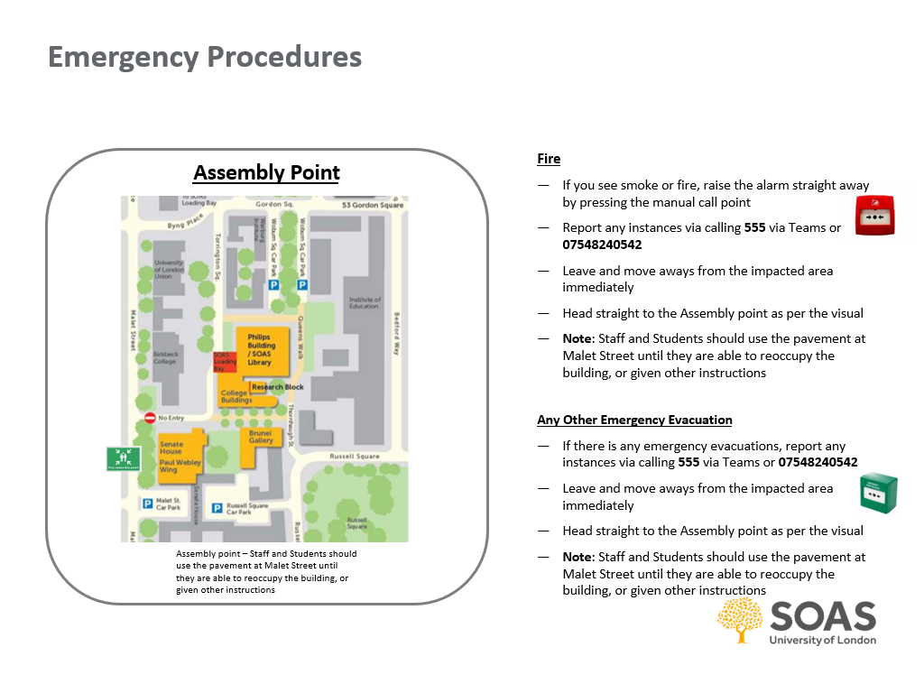
GDPR Privacy Notice
Data Collection
As part of the SOAS Event Risk Assessment process, we collect personal data including names, contact details, and other relevant information.

Purpose
The data collected is used solely for the purpose of assessing and managing risks associated with the event. This includes ensuring compliance with legal and safety requirements.

Data Storage
Your data will be stored securely and will only be accessible to authorized personnel involved in the event planning and risk assessment process. We will retain your data for as long as necessary to fulfil the purposes outlined in this notice.

Data Protection Rights
You have the right to access, rectify, or erase your personal data, as well as the right to restrict or object to its processing. To exercise these rights, please contact the SOAS Data Protection Officer at [insert contact email].

Contact Information
For any queries or concerns regarding data protection, please contact:
- Data Protection Officer
- Email: dataprotection@soas.ac.uk

By completing this form, you consent to the collection and use of your personal data as described in this notice.

